1. For each consistency error in Figure 1, you should identify the consistency rule violated and suggest possible resolutions of the error. The ERD has generic names to help will concentrate on finding diagram errors rather than focusing on the meaning of the diagram



Figure 1: ERD for Problem 4

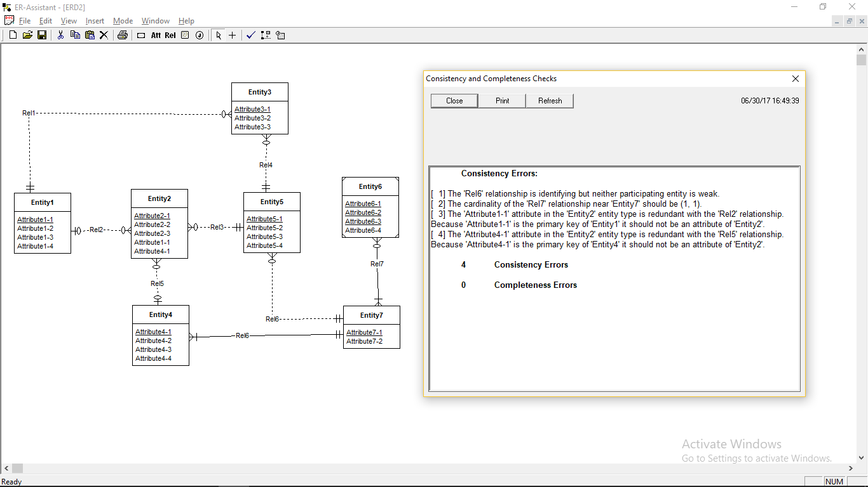

Below is also reference to above example mentioning violation rules.



**Suggestions:**

Follow these rules while designing an ER-diagram.

Identification Dependency Rules

Redundant Foreign key rule violation

Weak entity type Rules

Primary key Rule

M-N Relation Rule